How To Use TMS
- How to log in to TMS
Please contact the technical support personnel of dspread to obtain a login address and apply for a login account
- Register device
- Enter menu Device Mgmt->Devices
- Click Add button
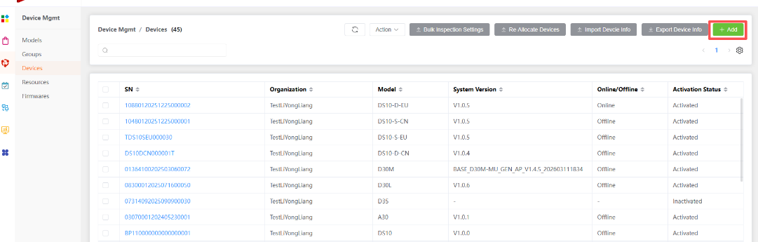
- Input Sn and select device model, then click Save button
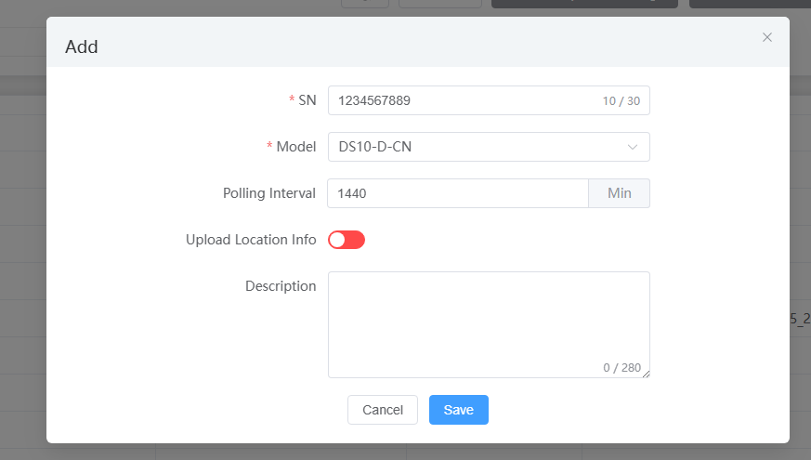
- Upload Firmware OTA package
- Enter Menu: Device Magmt->Firmwares
- Click Add button

- Upload Firmware OTA package
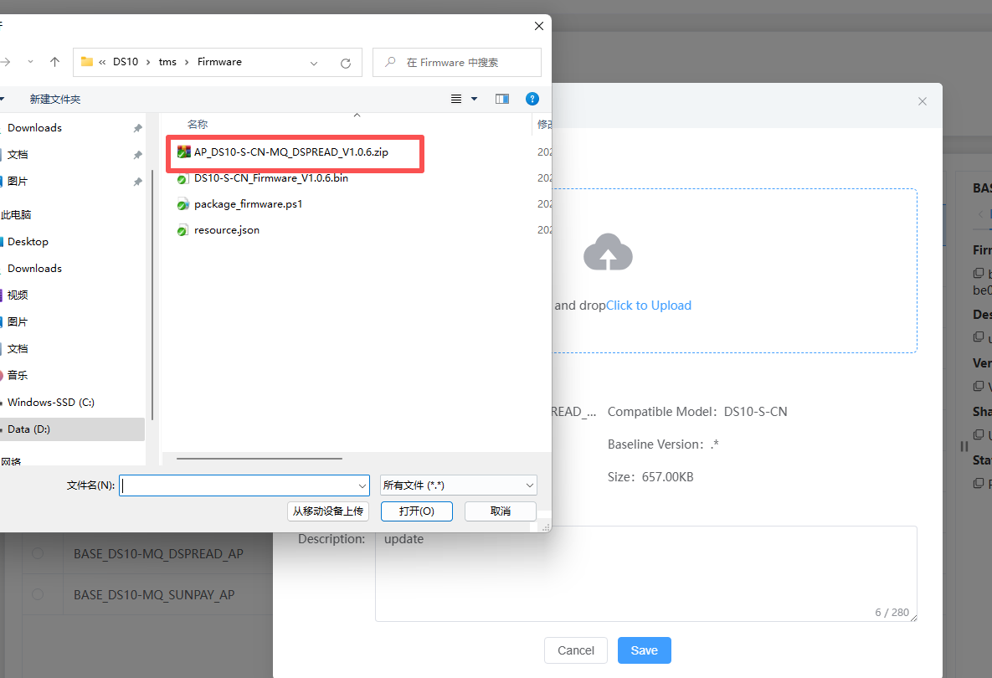
- Publish the firmware package that was just uploaded
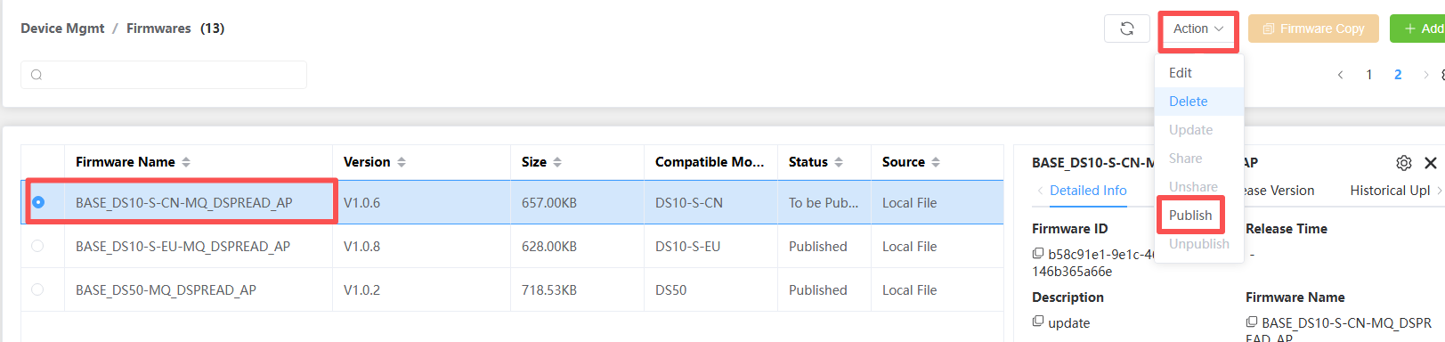

The status will changed to Published.
- Upload Param and Voice OTA package
- Enter Menu: Device Magmt->Resources

The other steps are basically the same as the operations in 3.2, 3.3, and 3.4
- Push update Task
- Enter Menu: Task Center->OTA
- Click Add button
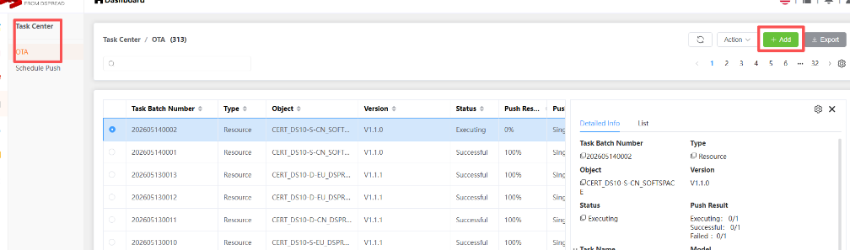
- Select the task Type and Object
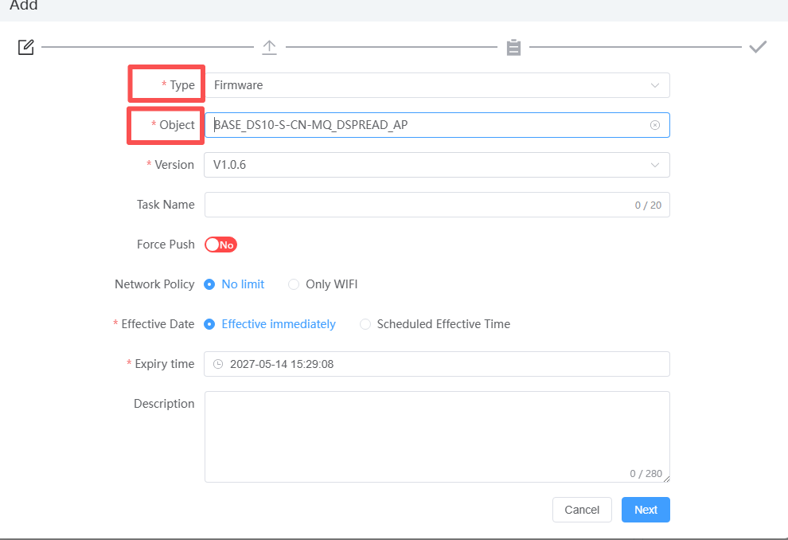
Please note that firmware update tasks and resource update tasks are supported here Resources include two types: parameters and audio
- Click Next button
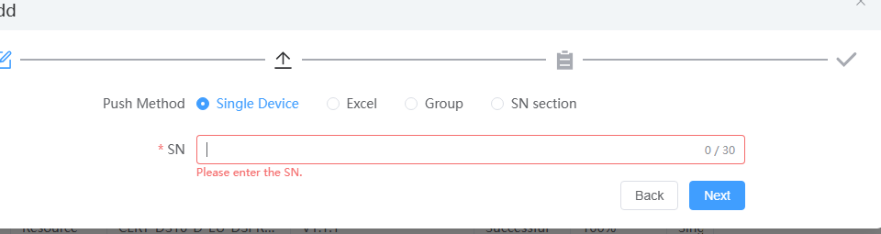
- Input sn and click Next button
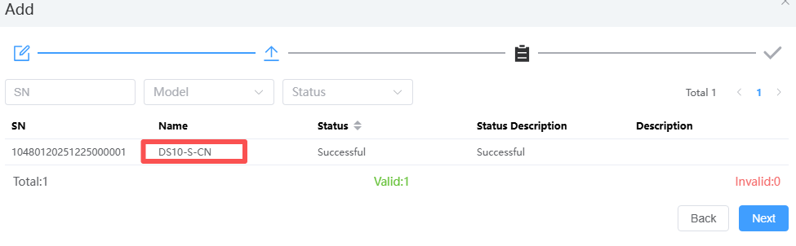
- Click Next button and close button. The task create successful.
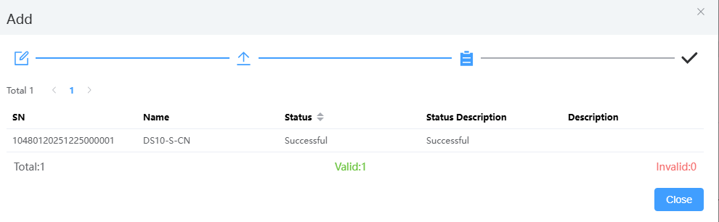
- You can check the task status.
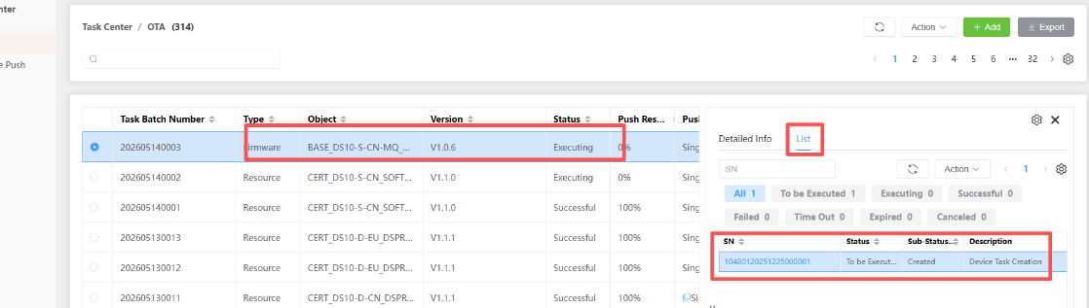

The above is just a demonstration of push notifications for a single device. The system also supports batch device push tasks. Arrange tasks and other functions,please refer to the online guidebook for detailed job functions

